Project Design Phase

Solution Architecture
Date | 28 October 2026
Team ID | ________________
Project Name | IMovies – Movie Ticket Booking System
Maximum Marks | 4 Marks

Solution Architecture:
IMovies uses the MERN stack to provide a centralized, responsive movie-ticket booking platform. React handles the user interface, Node.js and Express.js expose backend APIs, and MongoDB Atlas stores application records. The architecture separates presentation, application logic and data storage to support maintainability and secure access.
- Movie discovery: Browse and search movie listings, posters, descriptions and available showtimes.
- Seat booking: View an interactive seat map, select seats and validate availability before creating a booking.
- Authentication: Register and log in using hashed passwords and JSON Web Tokens (JWT); restrict admin operations by role.
- Booking management: Save booking records, show booking history and support cancellation workflows.
- Administration: Authorized administrators can add and manage movie listings and show information.
- Payment: A demo payment/confirmation flow may be used for the college prototype; production payment gateway integration is a future enhancement.

Technology Layers
Layer | Technology and Responsibility
Presentation | React + Vite; responsive movie, authentication, seat and booking pages
Application/API | Node.js + Express.js; routes, controllers, validation and booking logic
Security | bcrypt password hashing, JWT sessions and role-based authorization
Data | MongoDB Atlas + Mongoose; users, movies/showtimes and booking records

Example – Solution Architecture Diagram:
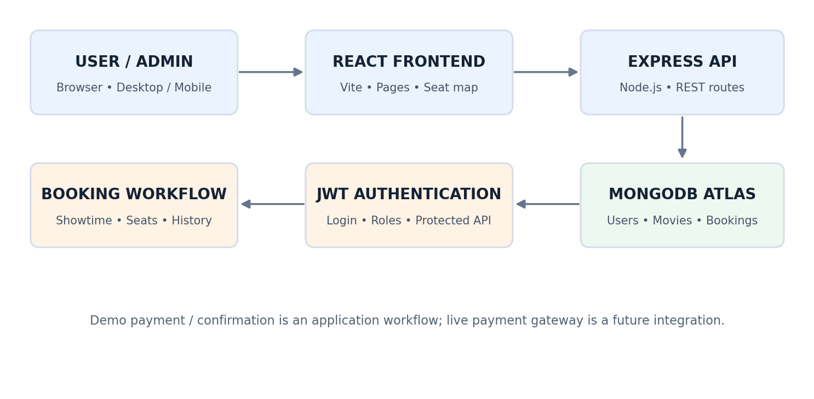

Typical Booking Data Flow
User selects a movie and showtime → React requests available seats → Express validates the request and checks stored bookings → MongoDB records a successful reservation → React displays confirmation and updates booking history.
Design consideration: Seat availability must be rechecked on the server when a booking is submitted; frontend seat selection alone does not prevent double booking.

